Christopher T. Junga, Esq.
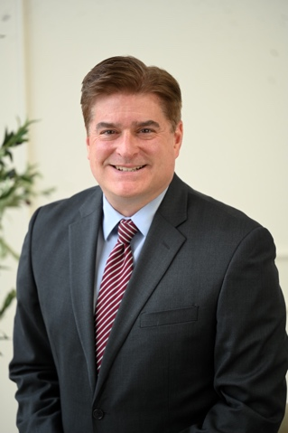
Candidate for: Franklin County Probate Judge
Undergraduate Education: BA, Political Science, University of Toledo, 1997
Legal Education: JD, University of Toledo College of Law, 1999
Legal Experience:
Christopher T. Junga is a veteran trial attorney with more than 25 years of legal experience in criminal, civil, family, probate-related and professional-malpractice matters.
- Tried more than 100 jury trials to verdict as lead counsel.
- Served as Director of the Ross County Office of the Ohio Public Defender and as Interim Chief Public Defender and Senior Assistant Public Defender in Delaware County.
- Led attorneys and professional staff, recruited and trained legal personnel, and managed office operations, personnel matters and public budgets of up to $2 million.
- Developed policies and collaborated with judges, prosecutors, county officials, law-enforcement agencies and state leaders to improve court and agency operations.
- Represented individuals, families, healthcare professionals, hospitals and businesses in complex and high-stakes legal matters.
- Maintained substantial caseloads while earning a reputation for preparation, sound judgment, professionalism and respect for the courts and opposing counsel.
- Practiced in courts throughout Ohio and is admitted to the United States District Court for the Southern District of Ohio.
- Recognized by Ohio Super Lawyers as a Rising Star and currently certified by the Supreme Court of Ohio to represent defendants in capital cases.

Candidate Statement:
I am running for Probate Judge because I believe Franklin County families deserve a judge with extensive courtroom experience—one who has represented and understands the needs of real clients. Franklin County deserves a court that is timely, responsive, and respectful to its litigants, led by a judge who possesses administrative leadership and the temperament to make thoughtful and fair decisions.
A Probate Judge must do more than preside over a courtroom; the role also requires effectively managing a branch of county government that is accessible, efficient, and responsive to the public. Probate Court impacts families navigating estates following the loss of a loved one, guardianships, adoptions, and the care of vulnerable individuals—issues that require legal experience, humanity, and a commitment to timely and effective service.
As a veteran trial attorney with more than 25 years of legal experience and more than 100 jury trials to verdict, I have handled complex criminal, civil, probate, and family matters. Throughout my legal career, I have represented individuals and families during some of the most difficult and high-stakes moments of their lives.
As a first-generation college graduate raised with blue-collar values, I worked my way through both college and law school before beginning my legal career at the Franklin County Public Defender’s Office, where I spent 12 years representing individuals in serious and complex cases. Later, I served in leadership roles in two Ohio public defender offices, leading attorneys and staff while responsibly managing office operations and providing fiscal oversight. My career also includes small-firm and private-practice experience.
In both the public and private sectors, I have built a reputation as a respected courtroom advocate known for preparation, integrity, sound judgment, and an unwavering commitment to fairness and justice. In recognition of my excellence in advocacy and legal service, I was named an Ohio Super Lawyers Rising Star.
My campaign has earned support from Republicans, Democrats, and Independents alike because of my experience, integrity, and commitment to doing what is right for all of Franklin County.
I reside in Upper Arlington with my wife, Sarah, and together we are the proud parents of five children in our blended family.

